Connections in Contrast: An Analytical Comparison of Performance Between Frame Relay, PPP, & MPLS

John Lorenzo Tapia
College of Computer Studies
De La Salle University
Manila, Philippines
john_lorenzo_tapia@dlsu.edu.ph

Abstract— This paper provides a comparative analysis of three widely used data-link protocols—Frame Relay, Point-to-Point Protocol (PPP), and Multiprotocol Label Switching (MPLS)—focusing on their performance in packet transmission speed and convergence time. Drawing on a review of existing literature, the analysis is restricted to comparisons between Frame Relay and MPLS as well as PPP and MPLS. Sources for this review include the "Comparative Analysis of WAN Technologies" report, which details the performance distinctions between Frame Relay and MPLS, and the " Performance Evaluation of AMI Communication Network Using OSPF Routing Protocol and WAN Technologies" study, examining PPP and MPLS under similar parameters. Findings from these sources indicate that MPLS generally outperforms Frame Relay and PPP in both packet transfer speed and convergence efficiency, especially under high-demand conditions, while between Frame Relay and PPP, the latter generally outperforms the former. This paper synthesizes insights from these studies to evaluate the trade-offs in adopting each protocol based on operational speed and network resilience.
Keywords—Layer 2, Data link protocol, WAN, Frame Relay, PPP, MPLS, Packet transmission speed, Convergence time

Introduction
The rapid evolution of communication networks has spurred the development of diverse protocols to support wide area network (WAN) infrastructure. As organizations rely increasingly on high-speed, reliable networks for data transfer, choosing the right WAN protocol is critical. Each protocol has unique characteristics that impact performance, particularly in packet transmission speed and convergence time, which are vital to maintaining efficiency and minimizing downtime. Among the protocols in use, Frame Relay, Point-to-Point Protocol (PPP), and Multiprotocol Label Switching (MPLS) are prevalent, each offering distinct advantages and challenges based on specific network environments and use cases.
Frame Relay, a traditional WAN protocol, uses packet-switching technology to transmit data over virtual circuits, making it an efficient but sometimes limited choice due to longer convergence times and lower adaptability to changing network demands. PPP, primarily used in point-to-point communications, has gained traction for its simplicity and features like authentication and multilink capabilities, but it may lack the advanced traffic engineering functions required in complex network environments. In contrast, MPLS operates as a more modern, high-performance protocol that supports faster convergence and enhanced scalability by utilizing label-switching mechanisms, making it an ideal choice for complex, large-scale networks that demand low latency and high reliability.
A comparison between Frame Relay, PPP, and MPLS in terms of packet transmission speed and convergence time, two critical metrics that affect WAN performance, is the main goal set by this paper. Other metrics (such as reliability, security, scalability, cost) are out of the scope of this paper. The analysis is conducted through a review of existing literature, focusing specifically on comparative data from studies evaluating Frame Relay versus MPLS and PPP versus MPLS. Using these sources, this paper synthesizes the findings to provide a nuanced understanding of each protocol's strengths and limitations in terms of speed and resilience. This comparison will help guide network engineers and decision-makers in selecting appropriate WAN protocols based on their performance needs and network configurations.
In evaluating and comparing these protocols, it is important to recognize that they do not exist in isolation. Data-link protocols are often designed with interoperability in mind, allowing for the possibility of combining or layering them to achieve enhanced functionality or specific use cases. For example, the protocol “PPP in Frame Relay,” described in RFC 1973, integrates elements of both Frame Relay and PPP, while “PPP over MPLS,” specified in RFC 4618, demonstrates another hybrid approach. These combined protocols allow for extended functionality, optimizing performance by utilizing specific aspects of each underlying protocol. However, while such hybrid protocols illustrate the adaptability and interdependence within the field, the scope of this paper is limited to a focused examination of each protocol in its standard form. By maintaining this narrower focus, the analysis will remain precise, enabling a clearer comparison of their respective design philosophies, operational mechanisms, and typical use cases.

Review of Related Literature
To conduct an analytical comparison between the three selected data-link protocols, this paper will begin by reviewing three pieces of literature, each dedicated to a single protocol. These foundational texts will provide insights into the unique features, operational characteristics, and typical applications of each protocol, establishing a solid understanding of their individual strengths and limitations. Following this, two additional comparative studies will be reviewed, providing structured analyses and relevant benchmarking data that will support this paper's discussion and claims. Through these analyses, the paper will address each protocol’s performance, efficiency, and suitability across various networking scenarios.
“Frame relay: protocols, architecture, operation and performance” by Ray Hunt [1] provides a comprehensive tutorial on frame relay technology, covering its protocols, architecture, operational dynamics, and performance considerations, discussing frame relay’s role in the evolution from traditional networking methods like TDM (Time Division Multiplexing) and X.25, detailing its advantages in efficiency and scalability and exploring the mechanisms for congestion management and bandwidth allocation. The document states that frame relay technology provides a high-performance, elastic bandwidth solution well-suited for LAN-to-LAN interconnections and is integral to modern network systems due to its capability to handle high-volume, bursty data traffic efficiently. It distinguishes itself from older networking approaches, like X.25 and TDM, by providing direct connectivity with low delays, essential for applications like client-server interactions and distributed databases. Frame relay operates over a wide area, managing high-speed, intermittent traffic without requiring constant bandwidth allocation, thus enhancing both flexibility and cost-effectiveness. The protocol’s architecture minimizes overhead by simplifying packet handling and streamlining error management, allowing for rapid data throughput. While X.25 includes error control features, frame relay shifts this responsibility to end-user protocols, further enhancing processing speed. As for its effectiveness, it stems from its ability to dynamically allocate bandwidth using a virtual circuit system, with each connection marked by a Data Link Connection Identifier (DLCI). To manage congestion, the protocol incorporates both open and closed loop mechanisms. Open loop control includes marking frames for discard eligibility, while closed loop control involves feedback-driven bandwidth adjustment to avoid congestion, especially during data bursts. This technology supports statistical multiplexing, meaning unused bandwidth can be shared among active connections, optimizing overall network utilization. However, frame relay networks need careful configuration, particularly in setting the Committed Information Rate (CIR) and tuning congestion controls, to prevent performance degradation. These capabilities position frame relay as a crucial step towards ATM (Asynchronous Transfer Mode) networking for high-speed multimedia applications, with ATM handling higher speeds, whereas frame relay remains optimal for conventional data traffic. These and other features of frame relay outlined by Hunt give way to the advantages and disadvantages the author outlined at the end of the document, shown in Excerpt 1.
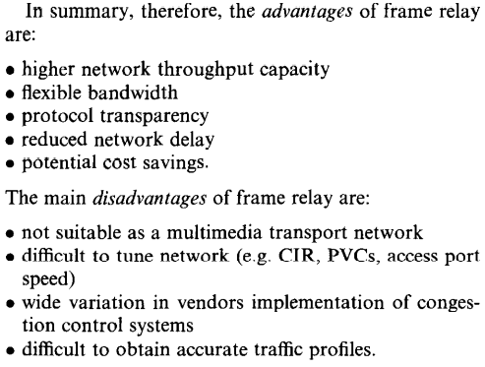
Excerpt 1 Advantages and disadvantages of frame relay
RFC 1661 by W. Simpson [2] defines the specification for the Point-to-Point Protocol, a standardized method for transmitting datagrams across point-to-point links. This protocol is designed to facilitate the connection and data transfer between two directly connected nodes, regardless of the type of data link layer. PPP operates at the data link layer and establishes a reliable communication environment by providing encapsulation for multi-protocol datagrams. Key features of PPP include its extensible Link Control Protocol (LCP), which handles link establishment, configuration, and testing, as well as its Network Control Protocols (NCPs), which manage the configuration of various network-layer protocols. The LCP is particularly critical in ensuring compatibility between the communicating nodes by negotiating link parameters and handling link errors, which contributes to a robust and flexible protocol suitable for diverse networking environments. The protocol's modular architecture supports a wide range of protocols and authentication methods, making it highly adaptable. Through its NCPs, PPP is capable of establishing and configuring multiple network-layer protocols, including Internet Protocol (IP), making it ideal for a variety of network setups such as dial-up and leased lines. Additionally, PPP incorporates optional authentication protocols, such as PAP (Password Authentication Protocol) and CHAP (Challenge Handshake Authentication Protocol), to secure connections (Excerpt 2). Error detection and support for compression protocols further enhance its performance over potentially noisy or low-bandwidth connections.
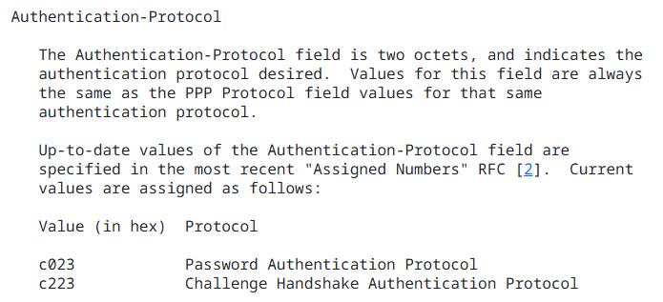
Excerpt 2 PAP and CHAP hex values used in PPP
In “MPLS Fundamentals” by De Ghein [3], MPLS is explored as a protocol that functions by attaching labels to packets, facilitating efficient packet forwarding through a network based on these labels rather than traditional IP lookups. This label switching mechanism contrasts with protocols like IP, as MPLS uses labels to identify packet-forwarding paths, enabling routers to determine packet forwarding without a complete IP route lookup. The architecture of MPLS comprises core elements like the Label Distribution Protocol (LDP) and Cisco Express Forwarding (CEF), which work together to maintain the MPLS forwarding table and enhance packet switching across networks. The primary motivations for MPLS adoption lie in its potential to streamline traffic across various network types, including ATM and Frame Relay. The unified infrastructure MPLS offers is essential for supporting diverse data types—from traditional IP packets to voice and video traffic—over a single backbone. Furthermore, MPLS VPNs have gained prominence as a preferred model for virtual private networks, owing to MPLS's label-based architecture that allows separation of customer traffic and ensures privacy across shared infrastructures​. Traffic engineering, a crucial aspect of MPLS, optimizes network performance by dynamically rerouting traffic along less congested paths, thereby improving resource utilization and overall network efficiency. MPLS also supports differentiated service levels through Quality of Service (QoS) models, such as DiffServ, enabling traffic prioritization and efficient handling of latency-sensitive data like VoIP. The study highlights the role of MPLS in enhancing network scalability and reliability, especially through techniques like Fast ReRoute (FRR), which quickly redirects traffic in case of link failures, maintaining service continuity. Beyond the fundamentals, the book looked ahead and explored that MPLS supports advanced protocols like IPv6, expanding its applicability as IPv4 addresses become exhausted. Any Transport over MPLS (AToM) and Virtual Private LAN Service (VPLS) exemplify how MPLS can encapsulate various Layer 2 protocols over a single MPLS backbone. AToM extends MPLS's utility by transporting Layer 2 protocols over MPLS, while VPLS enables Ethernet emulation, which is particularly beneficial for enterprises seeking scalable Layer 2 VPN solutions. Future MPLS developments are expected to integrate emerging applications, such as multicast traffic and enhanced operations and maintenance protocols, underscoring MPLS's adaptability and growing importance in network architecture​.
“Comparative analysis of WAN technologies” by E. H. Kaur and M. Gobindgarh [4] offers insights into three major WAN technologies: Dynamic Multipoint Virtual Private Network (DMVPN), Multiprotocol Label Switching, and Frame Relay. The paper emphasizes the different characteristics of each technology, with DMVPN enabling internet-based site connectivity, MPLS serving as a backbone for secure data transmission, and Frame Relay providing a simpler, though less versatile, connection method. DMVPN’s reliance on GRE (Generic Routing Encapsulation) and IPSec makes it a suitable option for businesses needing scalability with reduced configuration at the hub level. MPLS is particularly noted for its ability to provide separate routing tables and virtual private network (VPN) services, making it more suitable for service providers looking to maintain customer separation and enhanced traffic engineering. Frame Relay, while outdated, offers benefits for specific hub-and-spoke topologies but lacks the robustness of the other options. The study further evaluates these technologies across multiple performance indicators, including convergence time, security, and scalability. The performance analysis reveals that DMVPN offers efficient configuration and scalability for partial or full mesh VPNs but may lag in quality of service when compared to MPLS, especially for applications like VoIP. MPLS stands out in this analysis for its robust performance, as it can handle both IP and non-IP traffic with high stability due to its unique label-switching architecture, which reduces ISP core router overhead (Figure 1). Conversely, Frame Relay’s reliance on Layer 2 protocols limits its performance and scalability; it suffers from slower convergence times and higher latency, making it less competitive in modern, high-speed networks. Ultimately, the analysis concludes that while Frame Relay has limited applications today, DMVPN and MPLS are viable options depending on network requirements. MPLS emerges as the superior choice for large enterprises needing high scalability and QoS, particularly in managed environments where traffic engineering is essential. DMVPN, while more affordable and simpler to deploy over the public internet, provides a flexible solution for smaller businesses needing cost-effective connectivity. The study suggests that MPLS and DMVPN are best suited to future WAN deployments, with Frame Relay likely phased out due to its infrastructure limitations and inability to match the performance standards required by contemporary applications.
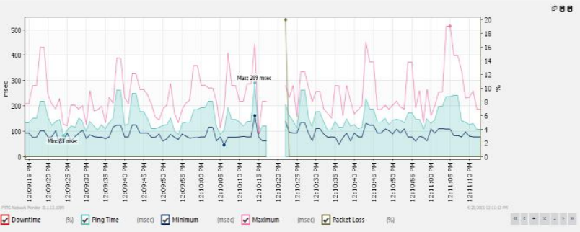
Figure 1 MPLS convergence shown in graph [4]
Lastly, the study “Performance Evaluation of AMI Communication Network Using OSPF Routing Protocol and WAN Technologies” by M. H. A. Hamied [5] examines the integration of advanced metering infrastructure (AMI) within smart grids to address the limitations of traditional electricity networks. AMI is critical for enabling two-way communication between utility operators and end-users, thus enhancing grid reliability and responsiveness. This integration of communication technologies within smart grids (Figure 2) aims to facilitate real-time monitoring and control, improved fault detection, and optimized energy management. By employing Open Shortest Path First (OSPF) routing protocols, which are designed for large, complex networks, the study explores how smart grids can better manage power distribution in real time through efficient routing of information and data across extensive, distributed networks. The study evaluates the effectiveness of various WAN communication technologies such as High-Level Data Link Control (HDLC), Point-to-Point Protocol, and Multiprotocol Label Switching within AMI networks. Through simulations conducted using GNS3 emulator and Wireshark for data capture, the researchers analyzed key performance metrics, including convergence time, throughput, and delay, across these protocols. The findings indicate that MPLS outperforms HDLC and PPP in terms of faster convergence time, higher throughput, and lower delay, making it more suitable for the fast-paced demands of smart grid communications. This improved performance is essential for the AMI network's ability to reliably and swiftly transmit meter data to centralized management systems, which in turn facilitates better grid management and faster response times to disruptions​. Moreover, the study addresses security and protocol efficiency challenges associated with smart grid communication. With OSPF as a dynamic routing protocol, it autonomously finds optimal paths, ensuring resilient communication even during network failures. The study also highlights how MPLS’s structured labeling system enables more efficient packet handling and routing, further underscoring its viability within AMI frameworks. Future research directions proposed include testing additional layer 3 protocols and exploring secure information exchange methods to mitigate risks associated with interconnected smart grid systems. Overall, this research underlines the critical role of advanced routing and WAN technologies in building robust, responsive, and secure AMI networks for smart grids.

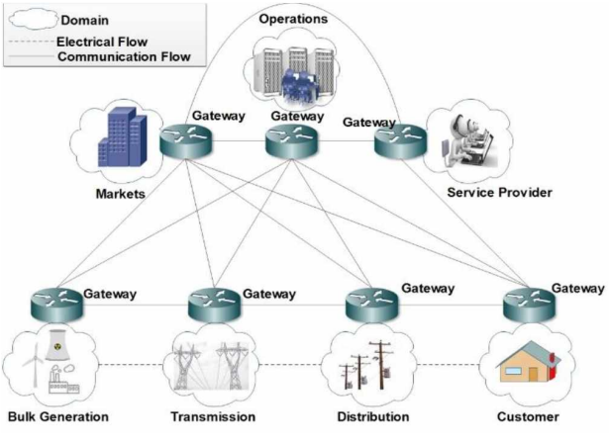
Figure 2 Communication network framework in the smart grid [5]

Analysis and Performance Comparison Between Frame Relay, PPP, and MPLS

Packet Transfer Speed
In the analysis of [4] and [5], it was observed that, as shown in Table 1, MPLS provides the highest throughput among the protocols. Specifically, in tests simulating AMI communications, MPLS reached a maximum throughput of 122,880 bytes, outperforming PPP and Frame Relay. PPP exhibited intermediate performance in packet transfer speed. With a maximum throughput of 102,400 bytes, it lagged behind MPLS but surpassed Frame Relay. PPP’s design includes features such as multilink capabilities, enabling load balancing over multiple paths, which enhances its performance for packet transfer compared to more traditional protocols like Frame Relay​, which, being an older technology, demonstrated the slowest packet transfer speed among the three protocols, with throughput typically capped at 67,584 bytes. Although Frame Relay is still suitable for some low-latency applications, its relatively limited data rate and reliance on shared circuits reduce its effectiveness in environments demanding high-speed, high-throughput data transfer.
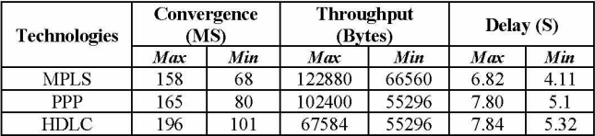
Table 1 Convergence, Throughput, and Delay in Different WAN Technologies [5]

Convergence Time
For convergence time, MPLS also performed the best, showing the shortest average convergence time when link failure occurred, achieving times as low as 3 to 4 seconds to reroute traffic. MPLS achieves faster convergence because it operates on Label Switched Paths (LSPs), which allow rerouting without needing to modify the packet header during transit. In OSPF routing scenarios within the MPLS network, convergence times were between 158 ms and 68 ms, further supporting its quick adaptability in network disturbances. PPP falls in the middle regarding convergence speed. It displayed a convergence time between 165 ms and 80 ms, slower than MPLS but faster than Frame Relay. PPP’s Layer 2 capabilities facilitate rapid recovery by maintaining a minimal state between point-to-point links, but its reliance on traditional routing metrics without advanced traffic engineering limits its speed compared to MPLS. Frame Relay showed the slowest convergence time, with delays exceeding 55-60 seconds in some configurations (Table 2). This slow response time is partly due to its outdated DLCI mechanisms, which lack the advanced rerouting capabilities seen in MPLS. Frame Relay's convergence time is also hampered by its dependence on the network provider’s infrastructure for managing virtual circuits, making it unsuitable for environments needing rapid failover solutions.
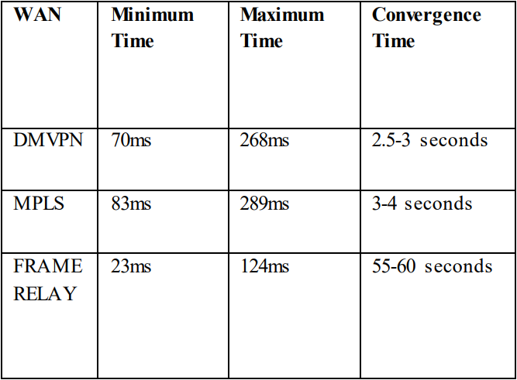
Table 2 Performance Analysis of WAN Protocols [4]

Performance Ranking Summary
Best Performance: MPLS – Superior in both packet transfer speed and convergence time due to its optimized label-switching technique and traffic engineering capabilities.
Intermediate Performance: PPP – Moderate in both packet transfer speed and convergence time, offering some enhancements over Frame Relay but not reaching MPLS's efficiency.
Lowest Performance: Frame Relay – Lags in packet transfer speed and has significantly slower convergence times, making it less viable for modern high-speed, real-time network demands

Methodology
The two studies assessed the performance of Frame Relay, PPP, and MPLS protocols through simulated environments that modeled WAN communications under varied conditions. In the study on AMI communication performance, the researchers implemented a network topology using GNS3 and Wireshark tools to capture and analyze traffic across different protocols in a simulated smart metering infrastructure. Their setup involved smart meters communicating through an OSPF routing protocol with key devices positioned in distinct network areas: the backbone (area 0) and a stub area (area 1) connected by an Area Border Router (ABR) serving as the network aggregator, shown in Figure 3 below. The tests recorded metrics such as throughput and convergence time under stable and failure conditions to simulate the resilience of each protocol in response to network interruptions​.

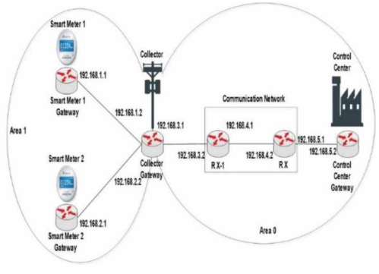
Figure 3 Topology used to test PPP and MPLS [5]
Similarly, the WAN comparative analysis study employed a controlled topology, emphasizing a hub-and-spoke structure to test DMVPN, MPLS, and Frame Relay protocols under variable link conditions (Figure 4 and Figure 5). Using Cisco 2821 and 1841 series routers, and leveraging Wireshark and PRTG monitoring tools, this study captured data such as minimum, maximum, and average response times, convergence speeds, and latency in a WAN environment that included both direct and fallback links. The researchers introduced simulated link failures to measure each protocol's failover performance and stability, with a particular focus on examining MPLS's Label Switched Paths under traffic load. This configuration emphasized MPLS’s advantages in rapid path switching, which contrasts with Frame Relay's reliance on slower DLCI mechanisms that resulted in delayed failover times and lower overall performance​.
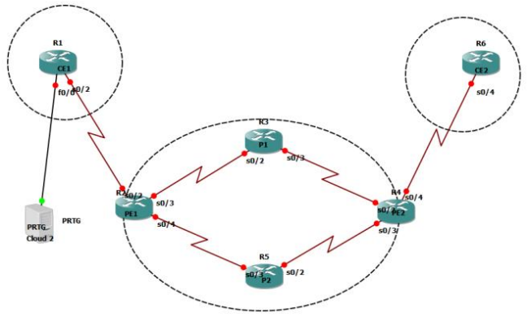
Figure 4 Topology used to test MPLS [4]
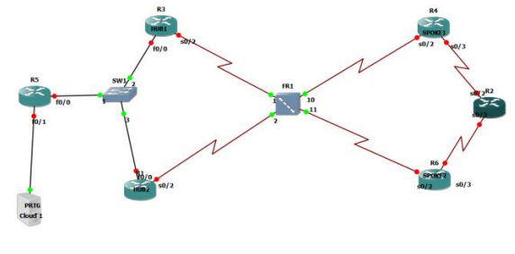
Figure 5 Topology used to test frame relay [4]
The selected topologies and experimental conditions favored MPLS by utilizing its strengths in label-switching and traffic engineering for faster data transfer and recovery times. Despite the use of different tools, router models, and simulated traffic loads, the performance ranking summary remains robust, as MPLS consistently demonstrated the best performance in both studies. PPP's moderate results stemmed from its limited yet effective point-to-point connection capabilities, while Frame Relay's inherent design limitations led to lower performance outcomes. Given the structural advantages of MPLS in handling packet-switched networks, the performance ranking is unlikely to change under similar experimental setups, with MPLS as the top performer, followed by PPP, and then Frame Relay.

Discussion of ChatGPT Results vs This Paper
To test the findings of this paper against the trained knowledge of ChatGPT (specifically, the model ChatGPT 4o mini), I prompted the model with the text shown in Figure 6, and the model responded with what is shown in Figure 7.

Figure 6 Prompt for ChatGPT to test the findings of this paper
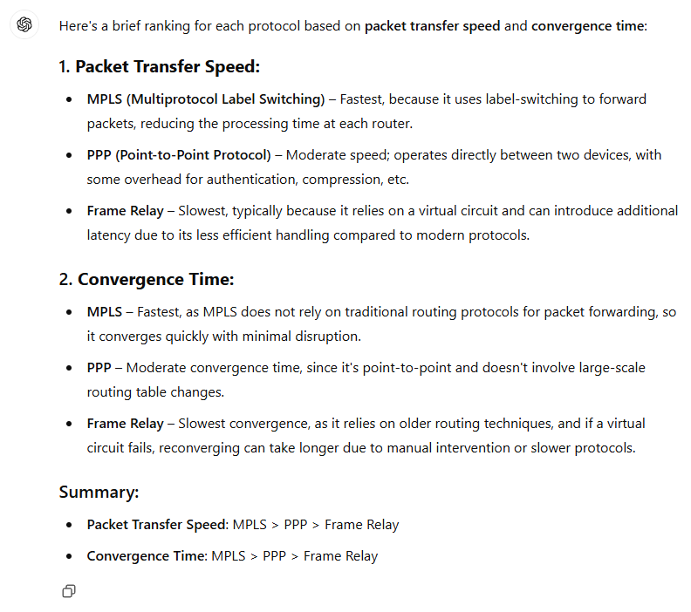
Figure 7 Response of ChatGPT
It can be observed that ChatGPT came to the same general conclusion as this paper has drawn in II.A.3) Performance Ranking Summary. The response of ChatGPT also contained some of the characteristics of the protocols also observed by this paper, like the label-switching feature of MPLS and the virtual circuit reliance of Frame Relay.

Conclusion
The comparative analysis of Frame Relay, PPP, and MPLS protocols reveals a clear performance hierarchy in terms of packet transfer speed and convergence time. Both studies demonstrate that MPLS consistently outperforms the other protocols due to its advanced label-switching mechanism, which reduces packet processing time and supports rapid rerouting, making it ideal for high-demand environments such as modern WANs and smart grid communications. PPP, while exhibiting some competitive characteristics, including relatively quick convergence in point-to-point setups, falls behind MPLS because it lacks the efficiency of label-based routing. Frame Relay, being a legacy technology, was the least performant, with limited throughput and notably slower convergence, largely attributed to its dependence on DLCI for routing and slower recovery protocols. These findings underscore MPLS's suitability for applications requiring fast and resilient network performance, positioning it as the preferred choice over PPP and Frame Relay.
Despite differences in study setups, tools, and network topologies, the performance ranking remains stable across both analyses. The methodologies confirm that MPLS’s structural advantages consistently allow it to manage network traffic with higher efficiency and adaptability than the alternatives. In scenarios with varying traffic loads or failure conditions, MPLS maintained its lead by rapidly rerouting data with minimal delay, while PPP provided moderate performance, and Frame Relay lagged due to its slower virtual circuit configurations and less efficient recovery processes. These consistent results reinforce that MPLS is the optimal protocol for advanced, latency-sensitive applications, with PPP suitable for simpler point-to-point connections, and Frame Relay being the least viable for modern high-speed demands.

References
- R. Hunt, “Frame relay: protocols, architecture, operation and performance,” Computer Communications, vol. 19, no. 9–10, pp. 830–847, Aug. 1996, doi: 10.1016/s0140-3664(96)01116-4.
- ‌W. Simpson, “The Point-to-Point Protocol (PPP),” Jul. 1994. doi: 10.17487/rfc1661.
- L. De Ghein, “MPLS Fundamentals,” 2006. [Online]. Available: https://dl.acm.org/citation.cfm?id=1206881
- E. H. Kaur and M. Gobindgarh, "Comparative analysis of WAN technologies," Int. J. Comput. Sci. Trends Technol., vol. 3, pp. 9-20, 2015.
- M. H. A. Hamied, “Performance evaluation of AMI communication network using OSPF routing protocol and WAN technologies,” 2020 International Conference on Computing and Information Technology (ICCIT-1441), vol. 57, pp. 1–5, Sep. 2020, doi: 10.1109/iccit-144147971.2020.9213743.

